Fwd: Assignment - Memory management

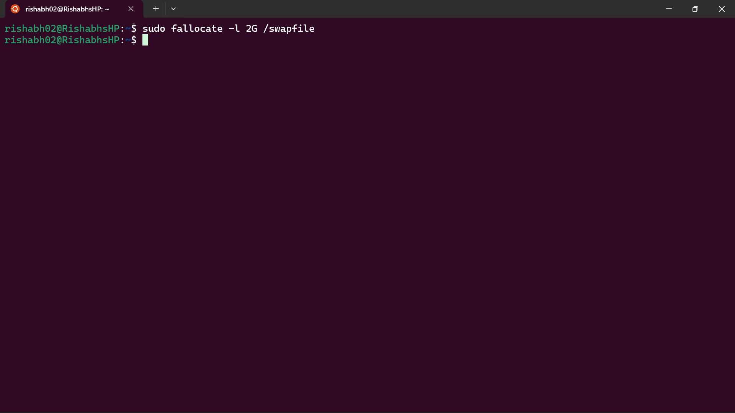
1) Setup additional swap space in the system to solve low memory issue. The swap which you added should be available post reboot.

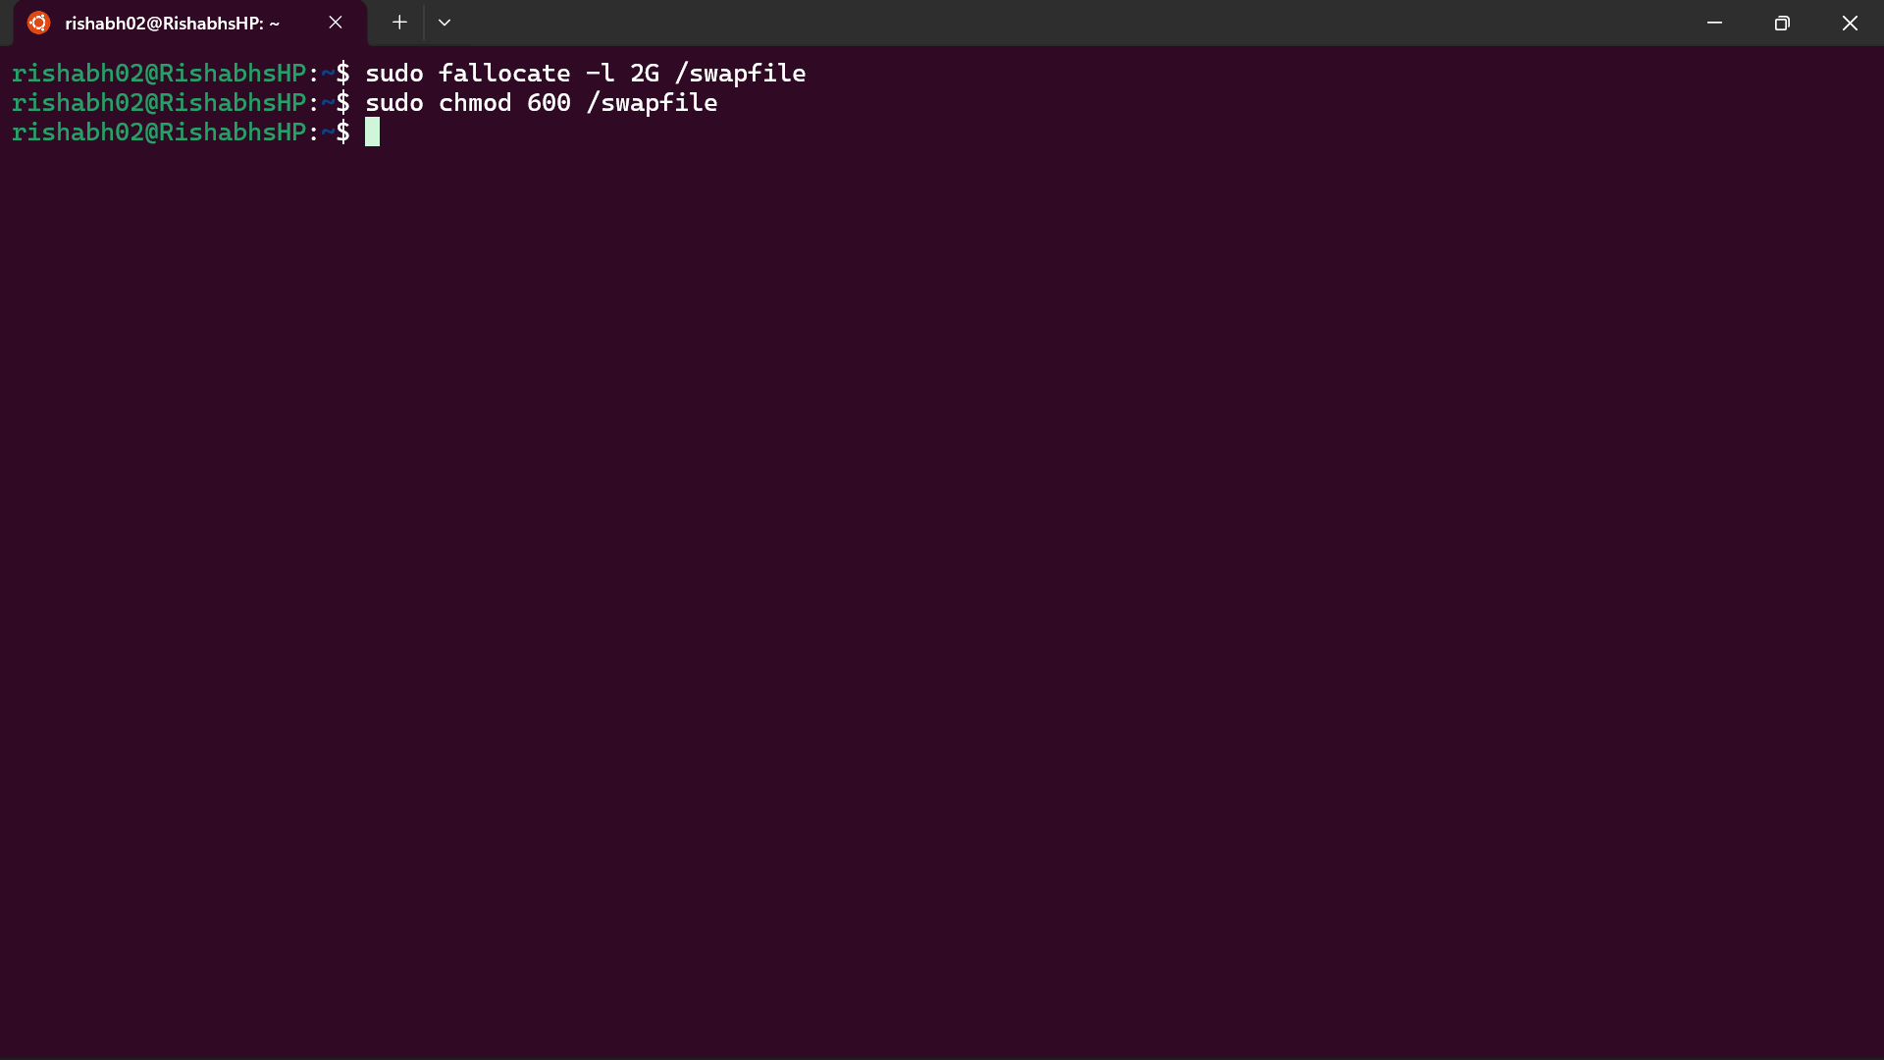

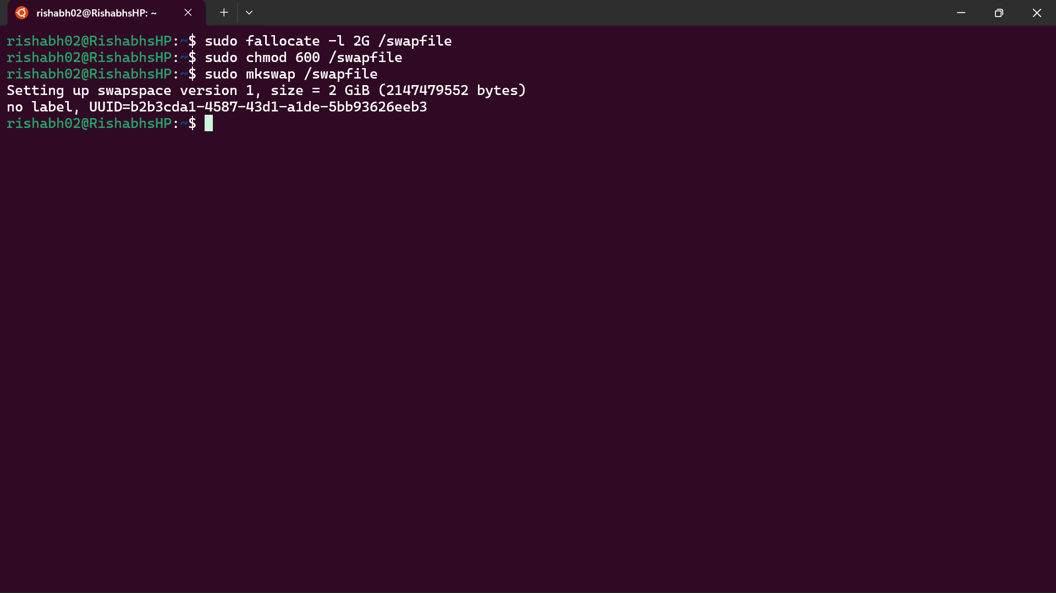

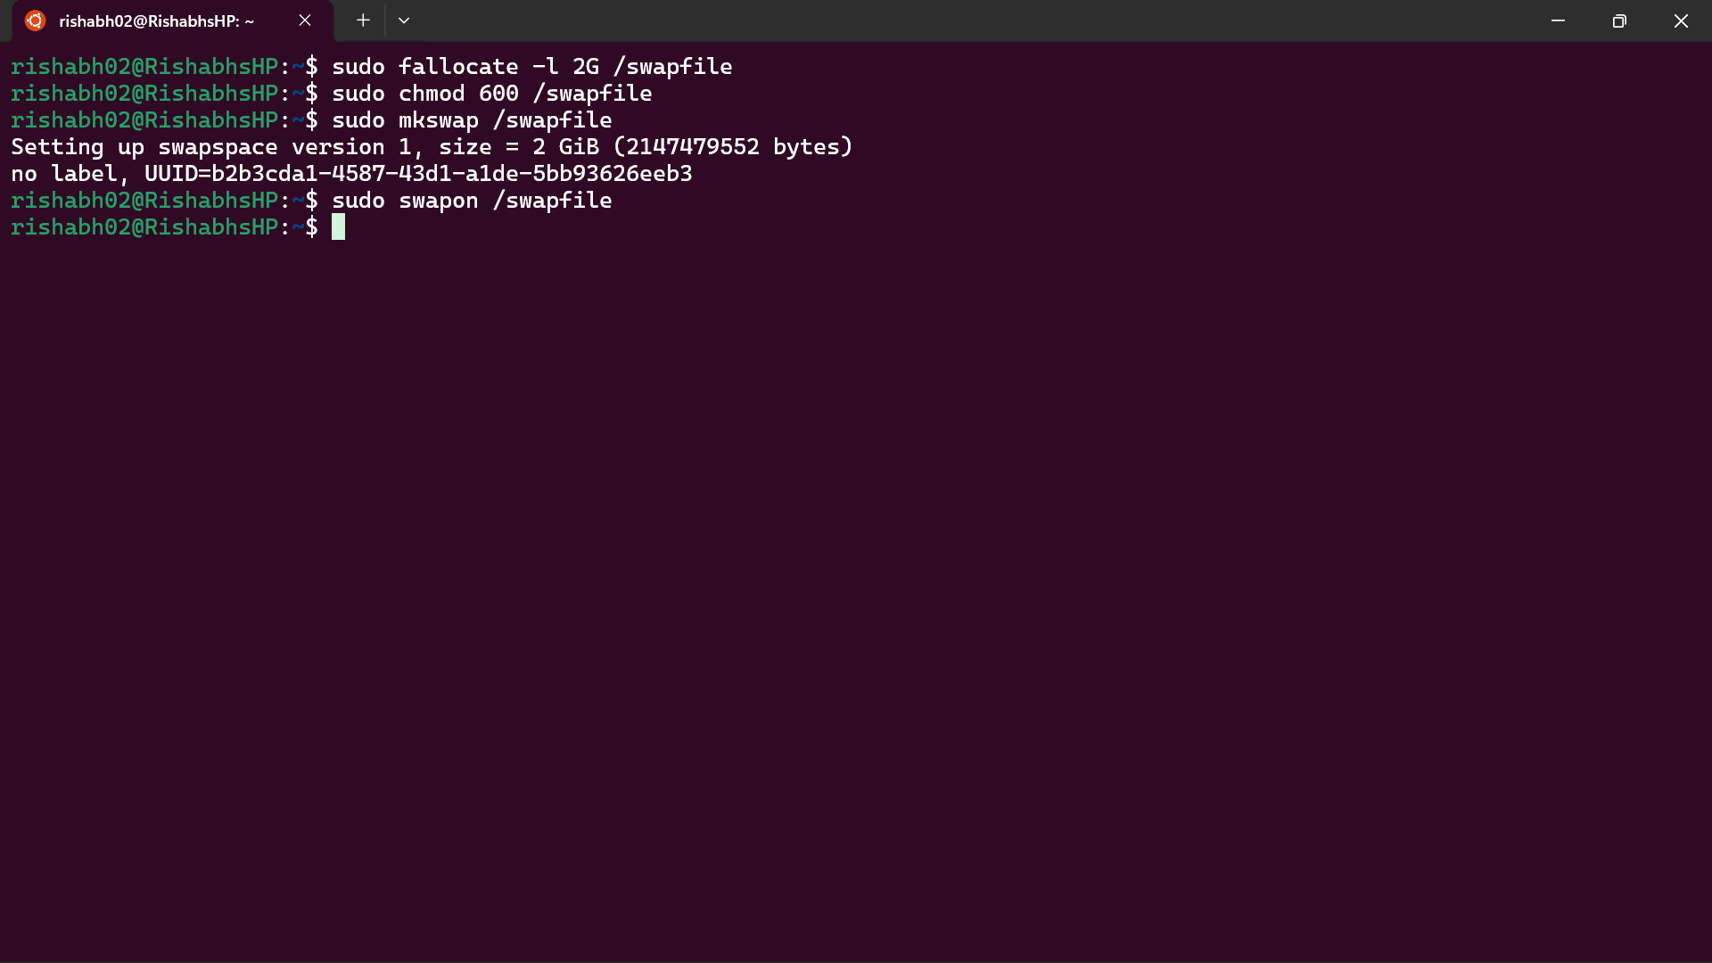

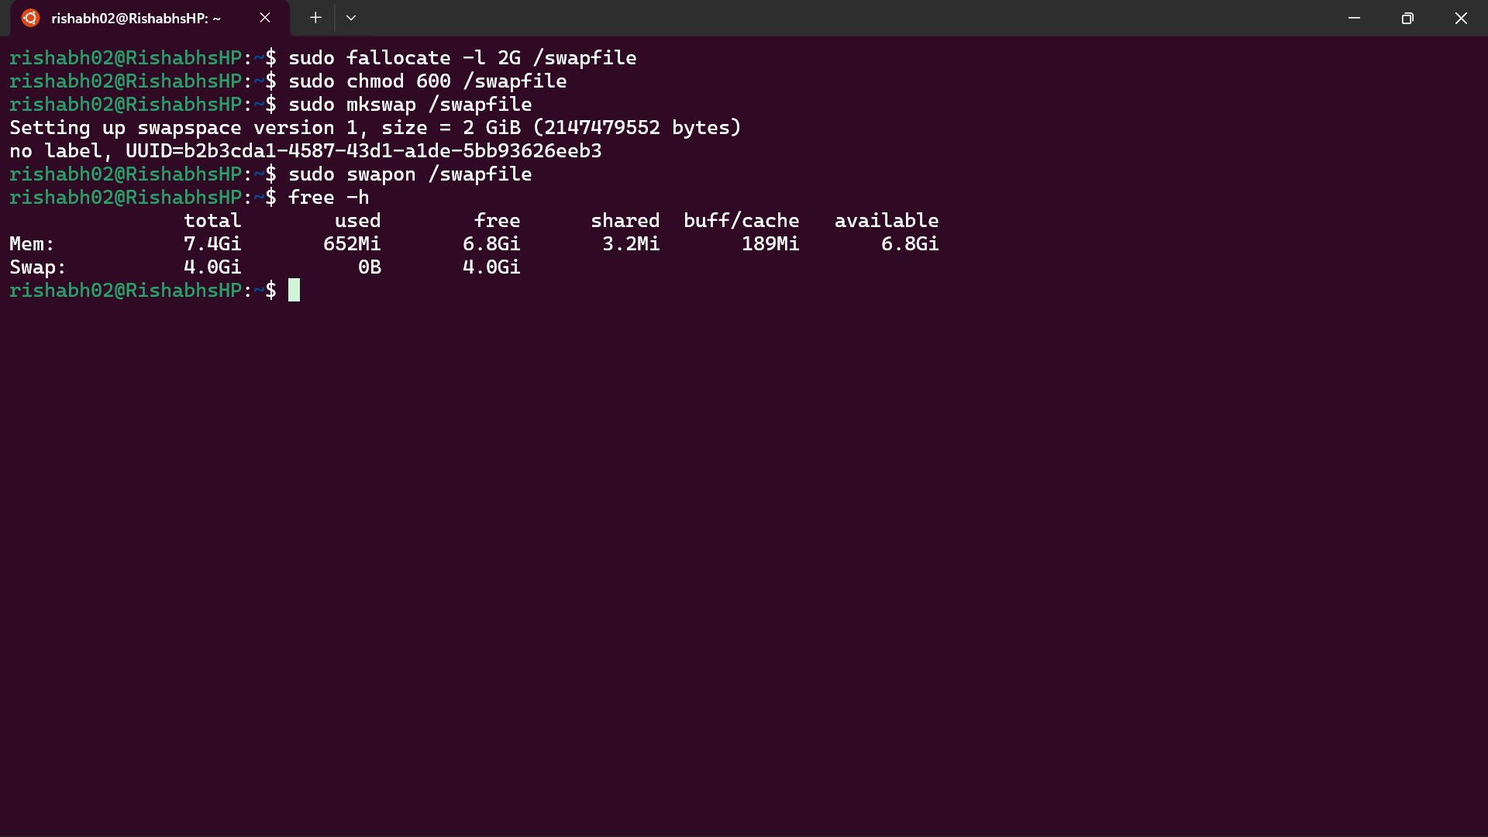

2) Find out the number of process is in run queue and blocking queue.
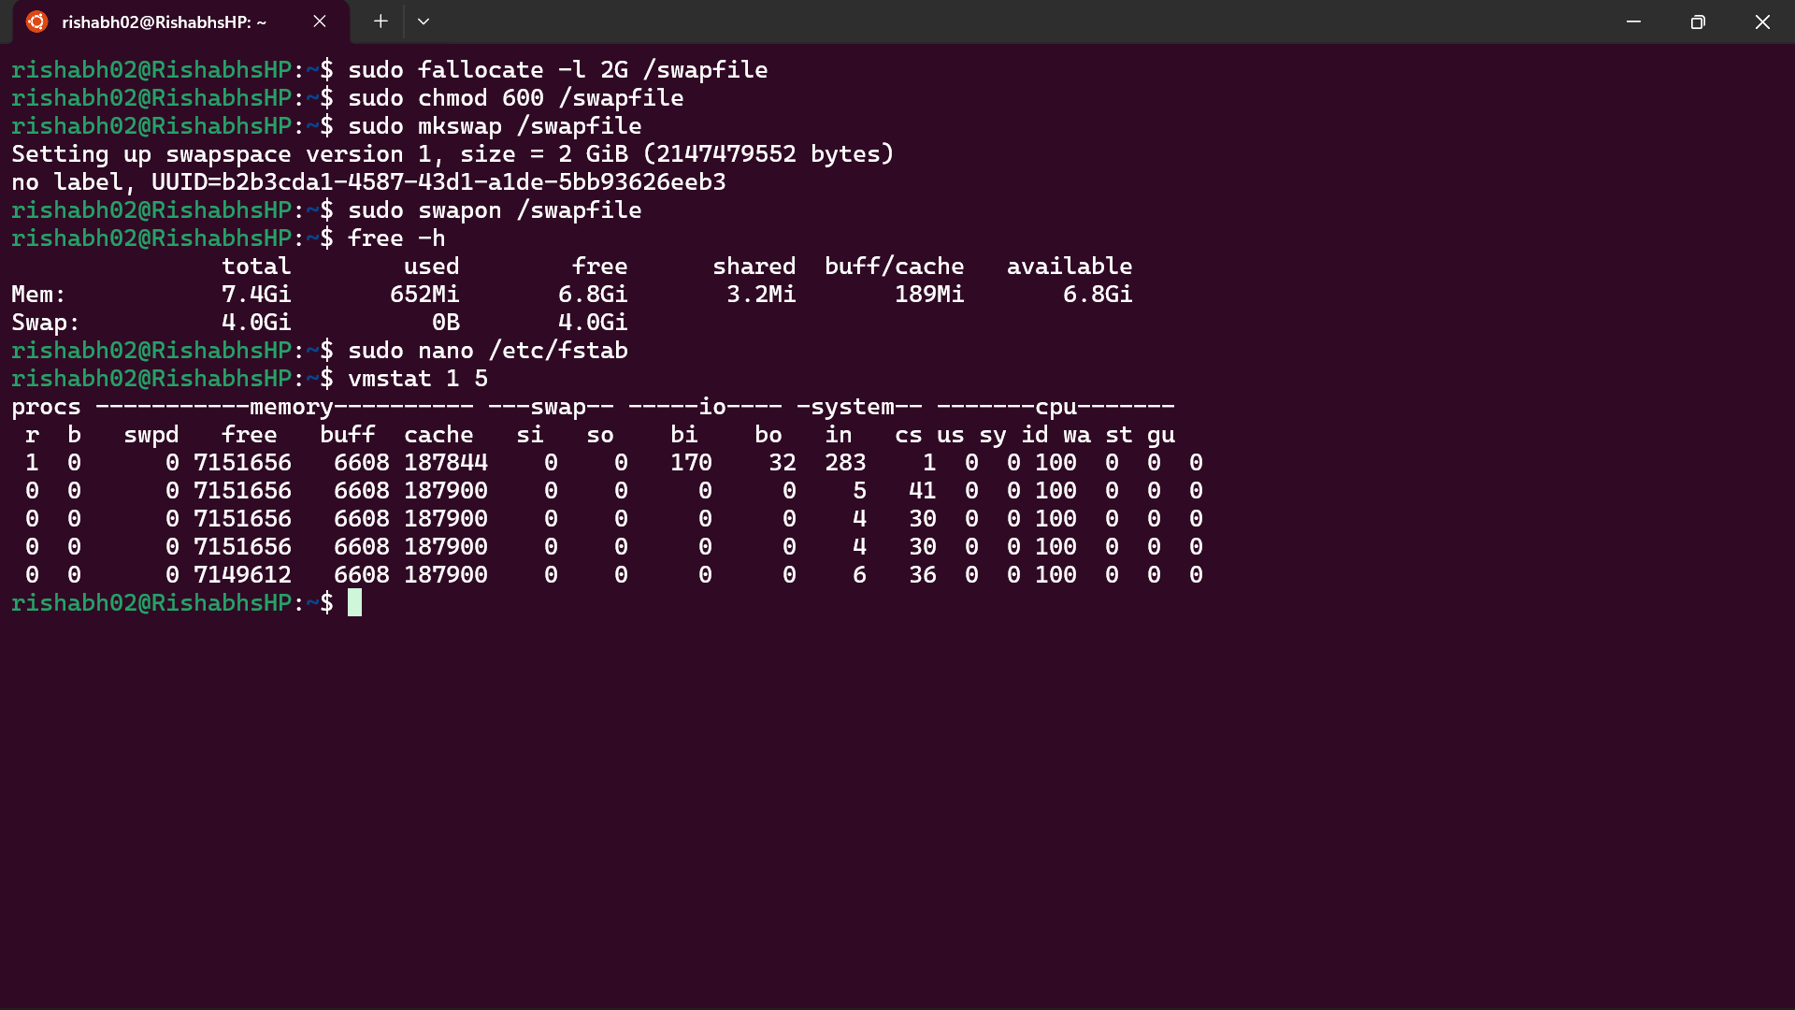

Explanation:-

1) Setup additional swap space (persistent after reboot)

Create swap file
Command:
sudo fallocate -l 2G /swapfile
Alternative (if fallocate not supported):
sudo dd if=/dev/zero of=/swapfile bs=1M count=2048

Set permissions
Command:
sudo chmod 600 /swapfile
Explanation:
Only root should have access to the swap file for security.

Create swap area
Command:
sudo mkswap /swapfile

Enable swap
Command:
sudo swapon /swapfile

Verify swap
Command:
free -h
or
Command:
swapon --show

Make swap permanent
Command:
sudo nano /etc/fstab
Add the following line:
/swapfile none swap sw 0 0
Explanation:
This ensures swap is enabled automatically after reboot.

Optional performance tuning
Command:
sudo sysctl vm.swappiness=10
Permanent setting:
echo "vm.swappiness=10" | sudo tee -a /etc/sysctl.conf

Explanation
Swap is a portion of disk used as additional memory when RAM is full. It helps prevent system crashes due to low memory, but it is slower than RAM.

2) Find number of processes in run queue and blocking queue

Using vmstat (recommended)
Command:
vmstat 1 5
Explanation:
- r column shows number of processes in run queue (ready to run or running)
- b column shows number of processes in blocking queue (waiting for I/O)

Example output
r b
2 1
Explanation:
2 processes are ready to run
1 process is waiting (blocked)

Alternative method to count blocking processes
Command:
ps -eo state | grep -c D
Explanation:
- D represents uninterruptible sleep (blocked I/O)

Alternative method to count running processes
Command:
ps -eo state | grep -c R
Explanation:
- R represents running or runnable processes

